Qs to Sharath
- Why we did not implement Test NG?
Because CME adopted the junit, cucumber tools, also dynamo was Junit compatible.
- Some errors seen while commit , what are these?
While commit, why all files are showing for commit, how to avoid these
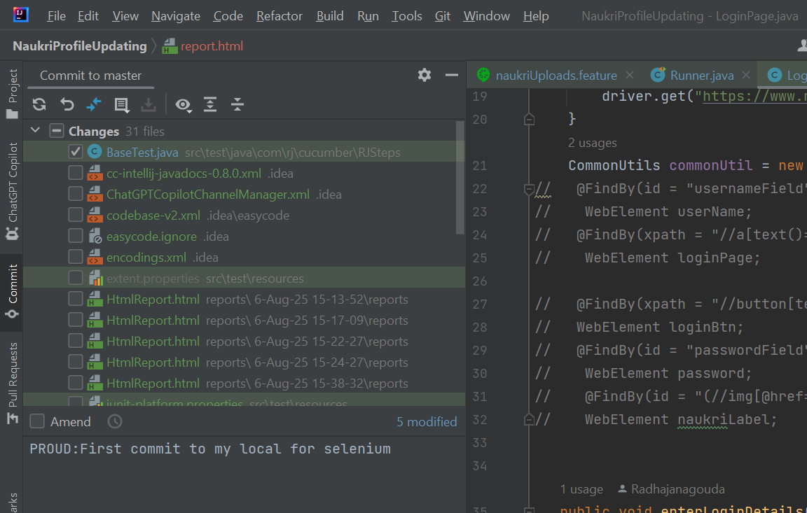
- Why we need to extend to use BaseTest methods across page classes?
- Structure on how to get ready for interview
- Mock interview check

